11.1-11.4 Extra Practice

____ 1. If , and , what is the measure of ?

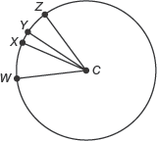

a.
b.
c.
d.

____ 2. If and , what is the measure of ?

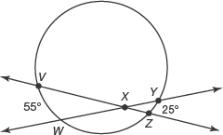

a.
b.
c.
d.

____ 3. A woodcarver draws cut lines on the top of a wooden disc. She uses the drawing of her design, as shown. In circle O, chords and are perpendicular to diameter . Which of the following relationships is true?

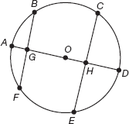

a.
b.
c.
d.

____ 4. Veronica copies a map of the paths in a park with circular picnic areas. On her map, lines AC and BF are tangent to circle D at points A and E, respectively. Also, lines AC and BF are tangent to circle G at points C and F, respectively.
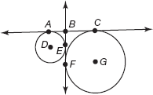
Which of the following statements is true?

a.
b.
c.
d.

____ 5. If and , what is the ?
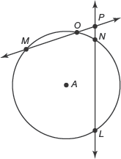

a.
b.
c.
d.

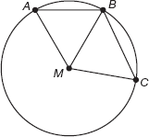
____ 6. A circular token in a board game has two triangles drawn on it, as shown. For which of the following conditions would in circle M?

a.
b.
c.
d.

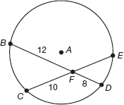
____ 7. In circle A, chords and intersect at point F. The lengths in feet of each segment are shown. What is the length of ?

a. | 4.8 feet
b. | 5 feet
c. | 9.6 feet
d. | 10 feet

____ 8. In circle G, inscribed angle measures x degrees. Which of the following describes the measure of ?
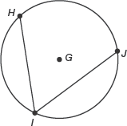

a. | 2x
b. | x
c.
d.

____ 9. Segments and are perpendicular to chords and . If is congruent to , and the length of is 10 millimeters, what is the length of ?
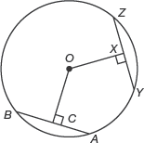

a. | 8 millimeters
b. | 9 millimeters
c. | 10 millimeters
d. | 12 millimeters

10. In circle B shown, .
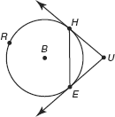

a. Determine .

b. Determine

11. In circle S shown, and . Determine .
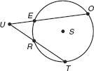

12. In circle X shown, and . Determine .

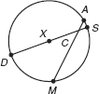

Use circle S to answer question 13-16.

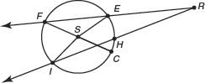

13. Suppose that . What is ?

14. Suppose that . What is ?

15. Suppose that . What is ?

16. Suppose that . What is ?

