**Chapter 3 Review – Area and Perimeter**

**#1-2, Find the area and perimeter of the rectangles:**

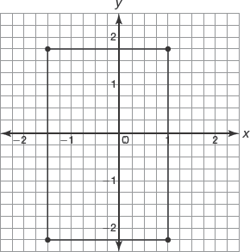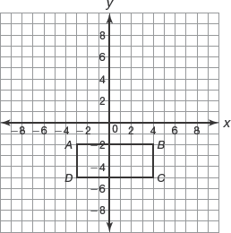

1. 2.

Area ____________ Area _____________

Perimeter _______________ Perimeter ________________

**#3-4, Find the area and perimeter of the squares.**

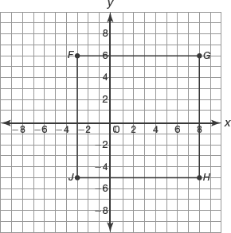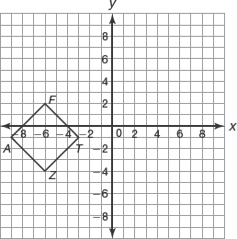

3. 4.

Area ____________ Area _____________

Perimeter _______________ Perimeter ________________

5. What happens to the area and perimeter of a rectangle with length 12 units width 7 units when its dimensions are increased by a factor of 3?

6. What happens to the area and perimeter of a rectangle with length 6 units and width 4 when each side length is decreased by a factor of ?

7. What happens to the perimeter of a rectangle with length 29 units and width 18 units when its dimensions are increased by 10 units?

**#8-9, Find the area and perimeter of the triangles.**

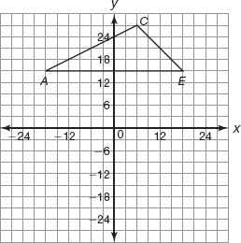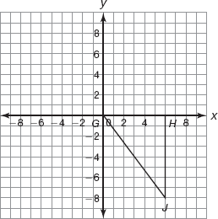

8. 9.

Area ____________ Area _____________

Perimeter _______________ Perimeter ________________

**#10-11, Find the area and perimeter of the parallelograms.**

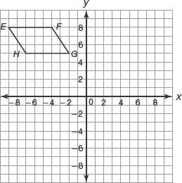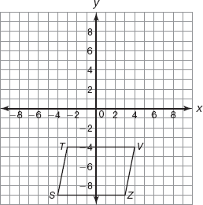

10. 11.

Area ____________ Area _____________

Perimeter _______________ Perimeter ________________

**#12-13, Find the area and perimeter of the trapezoids.**

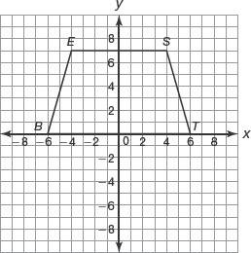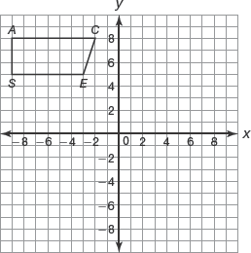

12. 13.

Area ____________ Area _____________

Perimeter _______________ Perimeter ________________

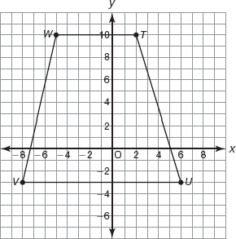14. Use the following trapezoid to answer the questions below.

**a.** Determine the perimeter of the quadrilateral.

**b.** Determine the area of the quadrilateral.

**c.** What happens to the perimeter of the quadrilateral if each side length is decreased by a factor of ?

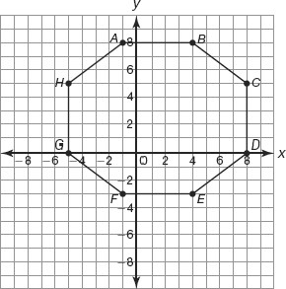15. Find the perimeter of the octagon.